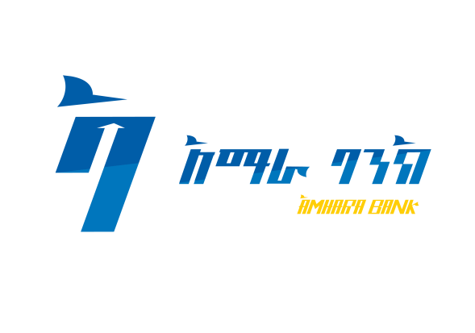 **Amhara Bank S.C**

**International Competitive Bid (ICB)**

**Invitation to International Competitive Bid (ICB)**

**Bid Reference Number: - ABa/PFMD/ICB/028/2025**

1. Amhara Bank S.C invites eligible Companies for **Supply and Implementation of Enterprise Transaction Reconciliation Solution.**
2. Bid document shall be obtained from the office of Procurement and Facilities Management Directorate located at Amhara bank Head office, ORDA Tower 20th floor Around Legahar, commencing April 29, 2025 up on payment of a **non-refundable** fee of **Birr** **500.00 (Five Hundred Birr Only)** by depositing at Amhara Bank S.C , Addis Ababa Branch Head office Ground floor during office Hours (Monday to Friday 8:00-12:00 A.M, 1:00- 5:00 P.M and Saturday 8:00 - 12:00 A.M).
3. Bid should be accompanied by a bid security with the amount of **800,000.00 Birr** **(Eight Hundred Thousand Birr)** in the form of **CPO or Unconditional Bank Guarantee** in favor of Amhara Bank S.C. with validity period not less than **120 days** from the date of bid (Technical) opening. Bid security issued from foreign banks shall be counter guaranteed by local banks. Bid bond guarantee issued from any Amhara bank branch will not be accepted.
4. Bidders should submit sealed bid documents to the address specified above before or on May 30, 2025 until 2:00 PM. The bids received after the closing time will be automatically rejected.
5. Bid opening shall be held in the presence of bidders and/ or their legal representatives who wish to attend on May 30, 2025 at 2:30 PM.
6. Presentation of copy of renewed Trade license, Tax clearance certificate and VAT registration certificate and other relevant documentary evidences is a must.
7. Interested eligible bidders may obtain further information from the office of Procurement Division Tell. +251-11-558-29-05/ +251-11-558-44-91
8. The Bank reserves the right to reject all or parts of this bid.

***Amhara Bank S.C***

***Beyond Financing!***